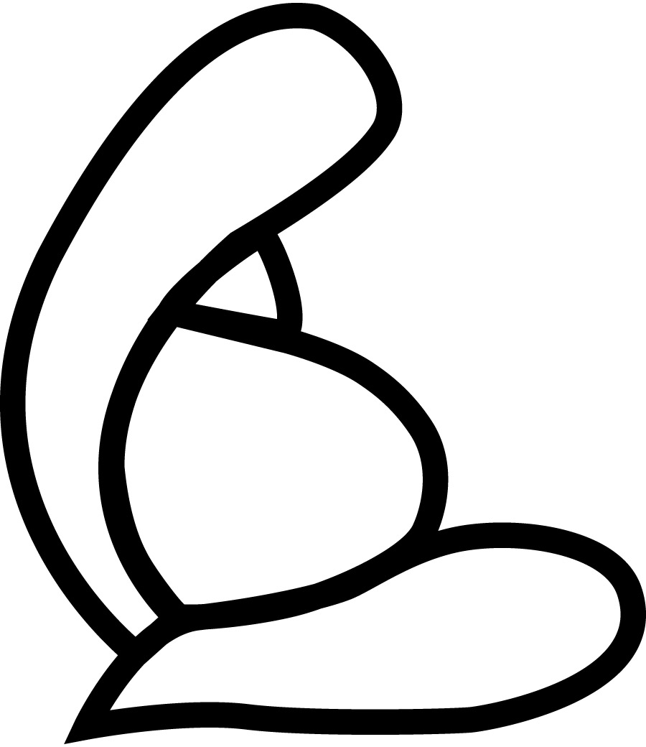

Natural BirthWorks Placenta Encapsulation Waiver

I, ____________________________________understand and acknowledge that in accordance to the Florida Drug and Cosmetic Act, Chapter 499 Florida Statues, choosing to encapsulate my placenta is not intended to prevent or treat any physical or mental diseases, ailments or symptoms and that I am choosing to consume my placenta for my own personal beliefs, whether it be spiritual or cultural.
I acknowledge that Natural BirthWorks has provided me with concrete information about both the benefits and risks of the placenta encapsulation, and have read all included documents. I understand that my placenta has been handled and encapsulated according to OSHA and Florida Food Safety Standards and has been cleaned, dehydrated and put into pill form in a sanitary and sterile work place. Upon receiving my placenta capsules from Natural BirthWorks, I waive any and all rights to hold the specialist responsible for any undesired effect of consuming the capsules.
I do not hold Natural BirthWorks responsible or liable for any transport mishap that is beyond their control (ie: car accident, or detainment) and understand that I am choosing to have the specialist encapsulate my placenta
In my home In specialists home
If my placenta is not encapsulated in my own home, I put full trust and acknowledgement that it is being handled in a sanitary and safe environment. I have provided Natural BirthWorks with blood documentation stating that I have been tested for STI’s and the results were negative. I understand and trust that Natural BirthWorks retains blood work records for each client and that I am protected.
I understand that upon receiving the pills, Natural BirthWorks is no longer liable, including but not limited to any other person(s) ingesting my own placenta capsules.
Once Natural BirthWorks has completed the encapsulation process it is my responsibility to make myself available for delivery/pick up and Natural BirthWorks is not responsible for holding capsules for more than 72hrs after completion.

mother signature phone date

